## The Rapture of the Church

The Rapture or Exit Resurrection of the Church is the return of the Lord Jesus Christ for Church Age believers at the end of the Church Age. Jesus Christ will be visible to believers only. The Rapture is shown in the following diagram of the dispensations of human history.

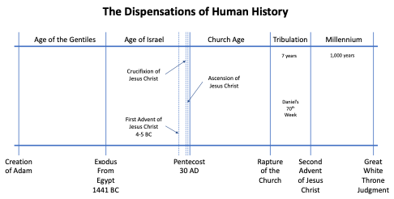

All Church Age believers (also members of the Body of Christ) who have died physically prior to the Rapture will be raised first and then those who remain alive on earth will be caught up to meet our Lord in the air. All believers alive on earth at the time of the Rapture, regardless of their spiritual status at the time (spiritual or carnal), will meet our Lord in the air. Our Lord Jesus Christ does not touch the earth. Heb. 2:10; 1 Thess. 4:16-17; Acts 1:11.

“For it was fitting for Him, for whom are all things, and through whom are all things, in bringing many sons to glory, to perfect the author of their salvation through sufferings.”  (Hebrews 2:10, NASB)

“For the Lord Himself will descend from heaven with a shout, with the voice of the archangel and with the trumpet of God, and the dead in Christ will rise first. Then we who are alive and remain will be caught up together with them in the clouds to meet the Lord in the air, and so we shall always be with the Lord.” (1 Thessalonians 4:16-17, NASB)

“They also said, "Men of Galilee, why do you stand looking into the sky? This Jesus, who has been taken up from you into heaven, will come in just the same way as you have watched Him go into heaven."” (Acts 1:11, NASB)

All Church Age believers receive a resurrection body that has no old sin nature. 1 Cor. 15:51-57.

"Behold, I tell you a mystery; we will not all sleep, but we will all be changed, in a moment, in the twinkling of an eye, at the last trumpet; for the trumpet will sound, and the dead will be raised imperishable, and we will be changed. For this perishable must put on the imperishable, and this mortal must put on immortality. But when this perishable will have put on the imperishable, and this mortal will have put on immortality, then will come about the saying that is written, "DEATH IS SWALLOWED UP in victory. "O DEATH, WHERE IS YOUR VICTORY? O DEATH, WHERE IS YOUR STING?" The sting of death is sin, and the power of sin is the law; but thanks be to God, who gives us the victory through our Lord Jesus Christ." (1 Corinthians 15:51-57, NASB)

The Rapture involves Church Age believers only. All Church Age believers are members of the Body of Jesus Christ by the Holy Spirit at salvation when He entered each believer into union with Jesus Christ (Baptism of the Spirit). Christ is the head of the body, the Church. Jesus Christ comes to receive His Church at the Rapture. The Church is a mystery doctrine, not revealed in the Old Testament. 1 Cor. 12:12-13; Col. 1:18; Eph. 3:1-5.

“For even as the body is one and yet has many members, and all the members of the body, though they are many, are one body, so also is Christ. For by one Spirit we were all baptized into one body, whether Jews or Greeks, whether slaves or free, and we were all made to drink of one Spirit.” (1 Corinthians 12:12-13, NASB)

“He is also head of the body, the church; and He is the beginning, the firstborn from the dead, so that He Himself will come to have first place in everything.” (Colossians 1:18, NASB)

“For this reason I, Paul, the prisoner of Christ Jesus for the sake of you Gentiles— if indeed you have heard of the stewardship of God's grace which was given to me for you; that by revelation there was made known to me the mystery, as I wrote before in brief. By referring to this, when you read you can understand my insight into the mystery of Christ, which in other generations was not made known to the sons of men, as it has now been revealed to His holy apostles and prophets in the Spirit;” (Ephesians 3:1-5, NASB)

The Rapture of the Church was prophesied and promised by the Lord Jesus Christ on the eve of His crucifixion. John 14:1-3.

“"Do not let your heart be troubled; believe in God, believe also in Me. "In My Father's house are many dwelling places; if it were not so, I would have told you; for I go to prepare a place for you. "If I go and prepare a place for you, I will come again and receive you to Myself, that where I am, there you may be also.” (John 14:1-3, NASB)

The time element for the Rapture is unknown. It will occur when the number of believers are sufficient to complete the formation of the Body of Christ. Only God knows that number. Eph. 2:21.

"in whom the whole building, being fitted together, is growing into a holy temple in the Lord," (Ephesians 2:21, NASB)

Believers go to heaven where their work will be evaluated at the Judgment Seat of Christ while the Tribulation is taking place on earth. 2 Cor. 5:10.

“For we must all appear before the judgment seat of Christ, so that each one may be recompensed for his deeds in the body, according to what he has done, whether good or bad.” (2 Corinthians 5:10, NASB)

At the Rapture, there will be no dealing with sin and evil on the earth. At the Rapture, there will be no changes in nature. Israel’s unconditional covenants will still remain unfulfilled.

**Our Guarantee of Resurrection At the Rapture**

Every human being (except Jesus Christ) is born spiritually dead because of the sin of Adam in the Garden. The result of faith belief in the work of Jesus Christ on the Cross for our sins, we have spiritual life in Him. 1 Cor. 15:20-23.

“But now Christ has been raised from the dead, the first fruits of those who are asleep. For since by a man came death, by a man also came the resurrection of the dead. For as in Adam all die, so also in Christ all will be made alive. But each in his own order: Christ the first fruits, after that those who are Christ's at His coming,” (1 Corinthians 15:20-23, NASB)

The Rapture is the completion of the redemption of the body. The believer receives a resurrection body exactly like that of Jesus Christ, which is called Ultimate Sanctification. The resurrection of our Lord Jesus Christ from the dead as the “first fruits” is our guarantee of our bodily physical resurrection at the Rapture. Phil. 3:20-21; 1 John 3:1-2.

“For our citizenship is in heaven, from which also we eagerly wait for a Savior, the Lord Jesus Christ; who will transform the body of our humble state into conformity with the body of His glory, by the exertion of the power that He has even to subject all things to Himself.” (Philippians 3:20-21, NASB)

“See how great a love the Father has bestowed on us, that we would be called children of God; and such we are. For this reason the world does not know us, because it did not know Him. Beloved, now we are children of God, and it has not appeared as yet what we will be. We know that when He appears, we will be like Him, because we will see Him just as He is.” (1 John 3:1-2, NASB)

**Enoch Was an Example of Miraculous Translation**

Enoch was the first man ever to be transferred or translated miraculously from one place to another and changed from one form to another. Gen. 5:24; Heb. 11:5.

“Enoch walked with God; and he was not, for God took him.” (Genesis 5:24, NASB)

“By faith Enoch was taken up so that he would not see death; AND HE WAS NOT FOUND BECAUSE GOD TOOK HIM UP; for he obtained the witness that before his being taken up he was pleasing to God.” (Hebrews 11:5, NASB)

Enoch did not die like the others before him like Adam, Seth, Enosh, and Kenan. Gen. 5:5; Gen. 5:8; Gen. 5:11; Gen. 5:14.

“So all the days that Adam lived were nine hundred and thirty years, and he died.” (Genesis 5:5, NASB)

“So all the days of Seth were nine hundred and twelve years, and he died.” (Genesis 5:8, NASB)

“So all the days of Enosh were nine hundred and five years, and he died.” (Genesis 5:11, NASB)

“So all the days of Kenan were nine hundred and ten years, and he died.” (Genesis 5:14, NASB)

Enoch was taken to Paradise because, according to John 3:13, no believer had ascended to the third heaven prior to our Lord Jesus Christ. Remember, this was written before the Cross, resurrection, ascension, and session of Jesus Christ. Enoch lived a long time prior to the writing of John 3:13.

“"No one has ascended into heaven, but He who descended from heaven: the Son of Man.” (John 3:13, NASB)

It was God who made this miraculous translation possible and it is God who will bring it about again at the Rapture of the Church when all Church Age believers will receive resurrection bodies that will live forever. Our resurrection bodies will be the same as that of the Lord Jesus Christ. This will not be resuscitation where the person dies again as did Lazarus. We will be changed forever.

**Waiting for the Rapture**

Every believer has a reservation in heaven guaranteed by God’s promise. 1 Peter 1:4; Eph. 2:6.

“to obtain an inheritance which is imperishable and undefiled and will not fade away, reserved in heaven for you,” (1 Peter 1:4, NASB)

“and raised us up with Him, and seated us with Him in the heavenly places in Christ Jesus,” (Ephesians 2:6, NASB)

All Church Age believers as members of the Church endure testing in their spiritual life because the Body of Christ is the target for the Angelic Conflict. The Rapture is the Christian’s hope and a source of comfort. 1 Thess. 1:10; 1 Thess. 4:18; Titus 2:13.

“and to wait for His Son from heaven, whom He raised from the dead, that is Jesus, who rescues us from the wrath to come.” (1 Thessalonians 1:10, NASB)

“Therefore comfort one another with these words.” (1 Thessalonians 4:18, NASB)

“looking for the blessed hope and the appearing of the glory of our great God and Savior, Christ Jesus,” (Titus 2:13, NASB)

We are to focus on consistent intake and application of the Word of God in our spiritual life. Spiritual growth and the fulfillment of God's plan for our lives is our purpose for being here on this earth. We can anticipate the return of our Lord at the Rapture, but our spiritual growth is to be the top priority in life. 2 Thess. 2:1-2.

“Now we request you, brethren, with regard to the coming of our Lord Jesus Christ and our gathering together to Him, that you not be quickly shaken from your composure or be disturbed either by a spirit or a message or a letter as if from us, to the effect that the day of the Lord has come.” (2 Thessalonians 2:1-2, NASB)

We are to learn to have patience by living the faith-rest life and using God's grace resources to deal with people, to solve our problems in life, and to make good decisions. We are to have confidence that the Rapture will occur and we will receive our resurrection bodies. James 5:7-8; Phil. 1:6.

“Therefore be patient, brethren, until the coming of the Lord. The farmer waits for the precious produce of the soil, being patient about it, until it gets the early and late rains. You too be patient; strengthen your hearts, for the coming of the Lord is near.” (James 5:7-8, NASB)

“For I am confident of this very thing, that He who began a good work in you will perfect it until the day of Christ Jesus.” (Philippians 1:6, NASB)

We are commanded to stay in fellowship (abide in Him) filled with the Holy Spirit and growing spiritually whereby we gain in the *epignosis* knowledge of God through His Word. 1 John 2:28; Col. 1:9-10.

“Now, little children, abide in Him, so that when He appears, we may have confidence and not shrink away from Him in shame at His coming.” (1 John 2:28, NASB)

“For this reason also, since the day we heard of it, we have not ceased to pray for you and to ask that you may be filled with the knowledge of His will in all spiritual wisdom and understanding, so that you will walk in a manner worthy of the Lord, to please Him in all respects, bearing fruit in every good work and increasing in the knowledge of God;” (Colossians 1:9-10, NASB)

Spiritual growth brings stability and spiritual discernment to the believer’s life. Isaiah 33:6; 2 Tim. 2:15.

“And He will be the stability of your times, A wealth of salvation, wisdom and knowledge; The fear of the LORD is his treasure.” (Isaiah 33:6, NASB)

“Be diligent to present yourself approved to God as a workman who does not need to be ashamed, accurately handling the word of truth.” (2 Timothy 2:15, NASB)

**Distinctions Between the Rapture and the Second Advent**

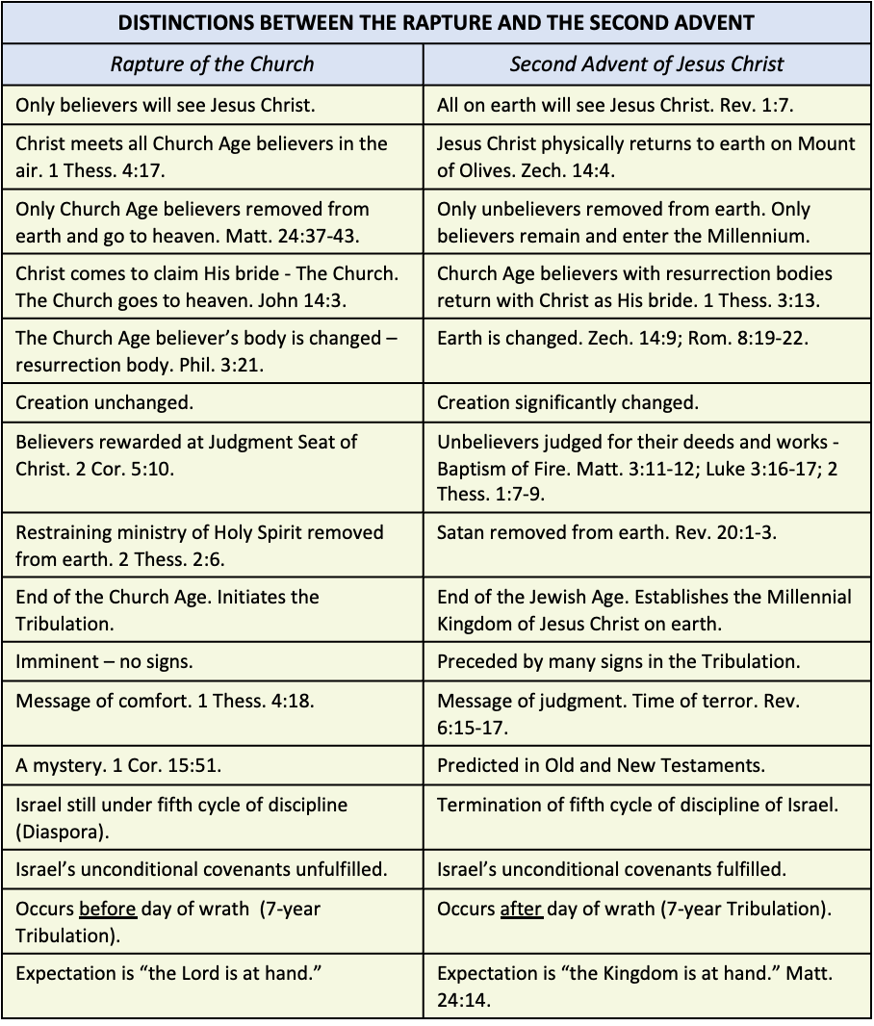

The Rapture involves the removal of all believers from the earth. The Second Advent involves the removal of all unbelievers from the earth. Matt. 24:37-43.

“"For the coming of the Son of Man will be just like the days of Noah. "For as in those days before the flood they were eating and drinking, marrying and giving in marriage, until the day that Noah entered the ark, and they did not understand until the flood came and took them all away; so will the coming of the Son of Man be. "Then there will be two men in the field; one will be taken and one will be left. "Two women will be grinding at the mill; one will be taken and one will be left. "Therefore be on the alert, for you do not know which day your Lord is coming. "But be sure of this, that if the head of the house had known at what time of the night the thief was coming, he would have been on the alert and would not have allowed his house to be broken into.” (Matthew 24:37-43, NASB)

The Rapture pictures the Church Age saints caught up to meet Jesus Christ in the air. At the Second Advent, our Lord Jesus Christ physically returns to earth at the Mount of Olives. Acts 1:11; Zech. 14:4.

“They also said, "Men of Galilee, why do you stand looking into the sky? This Jesus, who has been taken up from you into heaven, will come in just the same way as you have watched Him go into heaven."” (Acts 1:11, NASB)

“In that day His feet will stand on the Mount of Olives, which is in front of Jerusalem on the east; and the Mount of Olives will be split in its middle from east to west by a very large valley, so that half of the mountain will move toward the north and the other half toward the south.” (Zechariah 14:4, NASB)

At the Rapture, Christ comes to claim His bride – the Church. In the Second Advent He returns with His bride – the Church.

At the Rapture, the Church goes to heaven. At the Second Advent, the Church returns with Christ. John 14:3; 1 Thess. 3:13.

“"If I go and prepare a place for you, I will come again and receive you to Myself, that where I am, there you may be also.” (John 14:3, NASB)

“so that He may establish your hearts without blame in holiness before our God and Father at the coming of our Lord Jesus with all His saints.” (1 Thessalonians 3:13, NASB)

At the Rapture, the Church Age believers’ bodies will be changed. At the Second Advent, the earth will be changed. Phil 3:21; Zech. 14:9; Rom. 8:19-22.

“who will transform the body of our humble state into conformity with the body of His glory, by the exertion of the power that He has even to subject all things to Himself.” (Philippians 3:21, NASB)

“And the LORD will be king over all the earth; in that day the LORD will be the only one, and His name the only one.” (Zechariah 14:9, NASB)

“For the anxious longing of the creation waits eagerly for the revealing of the sons of God. For the creation was subjected to futility, not willingly, but because of Him who subjected it, in hope that the creation itself also will be set free from its slavery to corruption into the freedom of the glory of the children of God. For we know that the whole creation groans and suffers the pains of childbirth together until now.” (Romans 8:19-22, NASB)

Following the Rapture, Church Age believers will be judged for their use of God's grace resources while alive on earth at the Judgment Seat of Christ. At the Second Advent, unbelieving Gentiles and Jews will be judged and removed from the earth -the Baptism of Fire. 2 Cor. 5:10; Matt. 3:11-12; Luke 3:16-17; 2 Thess. 1:7-9.

““As for me, I baptize you with water for repentance, but He who is coming after me is mightier than I, and I am not fit to remove His sandals; He will baptize you with the Holy Spirit and fire. “His winnowing fork is in His hand, and He will thoroughly clear His threshing floor; and He will gather His wheat into the barn, but He will burn up the chaff with unquenchable fire.”“  (Matthew 3:11-12, NASB)

“John answered and said to them all, “As for me, I baptize you with water; but One is coming who is mightier than I, and I am not fit to untie the thong of His sandals; He will baptize you with the Holy Spirit and fire. “His winnowing fork is in His hand to thoroughly clear His threshing floor, and to gather the wheat into His barn; but He will burn up the chaff with unquenchable fire.”“  (Luke 3:16-17, NASB)

“and to give relief to you who are afflicted and to us as well when the Lord Jesus will be revealed from heaven with His mighty angels in flaming fire, dealing out retribution to those who do not know God and to those who do not obey the gospel of our Lord Jesus. These will pay the penalty of eternal destruction, away from the presence of the Lord and from the glory of His power,”  (2 Thessalonians 1:7-9, NASB)

Following the Rapture, the restraining ministry of the Holy Spirit will be removed. At the Second Advent, Satan is removed from the earth for 1,000 years. 2 Thess. 2:6; Rev. 20:1-3.

“And you know what restrains him now, so that in his time he will be revealed.” (2 Thessalonians 2:6, NASB)

“Then I saw an angel coming down from heaven, holding the key of the abyss and a great chain in his hand. And he laid hold of the dragon, the serpent of old, who is the devil and Satan, and bound him for a thousand years; and he threw him into the abyss, and shut it and sealed it over him, so that he would not deceive the nations any longer, until the thousand years were completed; after these things he must be released for a short time.” (Revelation 20:1-3, NASB)

The Rapture results in the removal of the Church and the inception of the Tribulation. The Second Advent results in the establishment of the Millennial Kingdom of Jesus Christ on earth.

The Rapture is imminent, while the Second Advent is preceded by many signs in the Tribulation.

The Rapture brings a message of comfort to Church Age believers, while the Second Advent is accompanied by a message of judgment and a time of terror. Rev. 6:15‑17.

“Then the kings of the earth and the great men and the commanders and the rich and the strong and every slave and free man hid themselves in the caves and among the rocks of the mountains;” (Revelation 6:15, NASB)

The Rapture is related to the program for the Church, while the Second Advent is related to the program for Israel and the world.

The Rapture is a mystery while the Second Advent is predicted in the Old and New Testaments.

The Rapture is the end of the Church Age. The Second Advent is the end of the Jewish Age.

The Rapture leaves creation unchanged while the Second Advent entails the change in creation.

At the Rapture, Gentiles are unaffected while at the Second Advent Gentiles are judged.

At the Rapture, Israel is under the fifth cycle of discipline. The Second Advent terminates the fifth cycle of discipline of Israel.

At the Rapture, Israel’s unconditional covenants are unfulfilled, but at the Second Advent all of Israel’s unconditional covenants will be fulfilled.

The Rapture is for believers only, but the Second Advent has its effect on believers and unbelievers.

The Rapture is said to take place before the day of wrath (the 7-year Tribulation), but the Second Advent follows it.

The expectation of the Church with regard to the Rapture is “the Lord is at hand,” while the expectation of Israel with regard to the Second Advent is “the kingdom is at hand.” Matt. 24:14.

""This gospel of the kingdom shall be preached in the whole world as a testimony to all the nations, and then the end will come." (Matthew 24:14, NASB)

The expectation of the Church at the translation is to be taken into the Lord’s presence, while the expectation of Israel at the Second Advent is to be taken into the kingdom. Thus, there must be two different programs - the first being the Rapture and the second one being the Second Advent.